provided by accelerometers and gyroscopes are used to track the position and orientation of an object relative to a known starting point, orientation and velocity. Inertial measurement units

three orthogonal rate-gyroscopes and three orthogonal accelerometers,

angular velocity and linear acceleration

position, velocity, orientation

 their cost and complexity

**integration drift**: small errors in the measurement of acceleration and angular velocity are integrated into progressively larger errors in velocity, which are compounded into still greater errors in position.

Remain unfinished material:

* GPS accuracy?

Map assisted:  
1. Levinson J, Montemerlo M, Thrun S. Map-Based Precision Vehicle Localization in Urban Environments[C]//Robotics: Science and Systems. 2007, 4: 1.

* LIDAR mapping 激光雷达 光脉冲 IMU&DGPS 记录激光发射点的瞬间空间位置和姿态。
* LIDAR : Remove vertical object, so only the flat ground is mapped, other vehicles are discarded from the data. Do not rely on external light.
* Map method: GraphSLAM + laser range finder
* Visualization of the scanning process: the LIDAR scanner acquires range data *and* infrared ground reflectivity. The resulting maps therefore are 3-D infrared images of the ground reflectivity. Notice that lane markings have much higher reflectivity than pavement.
* Map matching: drive the region twice and find the overlap to form a local map. Hardware accelerated OpenGL
* Particle filtering
* motion prediction based on inertial velocity measurement
* Sequence Importance Resampling & GPS Pose estimate
* Their particle filter can run entirely without GPS, where the only reference to the environment is the map
* Bayesian Filtering: From Kalman Filters to Particle Filters, and Beyond (2003) by Zhe Chen
* To avoid catastrophic localization errors, a small number of parti- cles are continuously drawn from current GPS pose estimate.

Particle Filtering:

预测 P(xk| z 1:k-1)

滤波 P(xk| z 1:k)

似然函数 P（xk|yk)

可以用蒙特卡洛采样来代替计算后验概率。

GPS model:

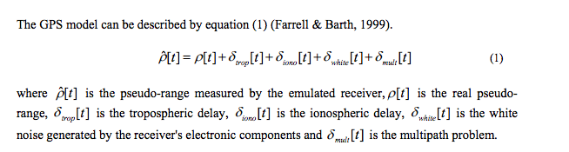

Drawil N M, Basir O. Intervehicle-communication-assisted localization[J]. Intelligent Transportation Systems, IEEE Transactions on, 2010, 11(3): 678-691.

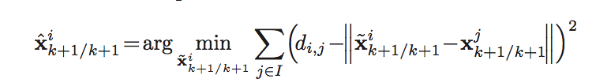

$${\hat{x}}_{k+1/k+1}^{i} =\arg_{{\tilde{x}}_{k+1/k+1}^{i}}min \sum_{j∈I}{(d_{i,j}}-\left\|{\hat{x}}_{k+1/k+1}^{i}-x_{k+1/k+1}^{j}\right\|)^{2}$$

$${\hat{x}}_{k+1/k+1}^{i} =\arg_{{\tilde{x}}_{k+1/k+1}^{i}}min \sum_{j∈I}{(\left\|d_{i,j}-{\hat{d}}_{i,j}\right\|}+\left\|{\tilde{x}}_{k+1/k+1}^{i}-x_{k+1/k+1}^{j}\right\|)$$

$${\hat{d}}_{i,j}=\left\|{\hat{x}}_{k+1/k+1}^{i}-x_{k+1/k+1}^{j}\right\|$$

$$\left\|I\right\| =3$$

$$x_{k+1/k+1}^{j}$$

Digital maps and visual features enhance GPS-DR localization by recognizing landmarks in the surrounding environment and matching them with others in a reference GIS map. A key problem associated with this scheme is that the landmark segmentation process is complex and ill conditioned process.

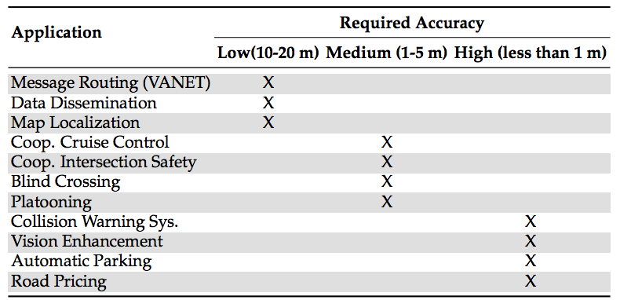

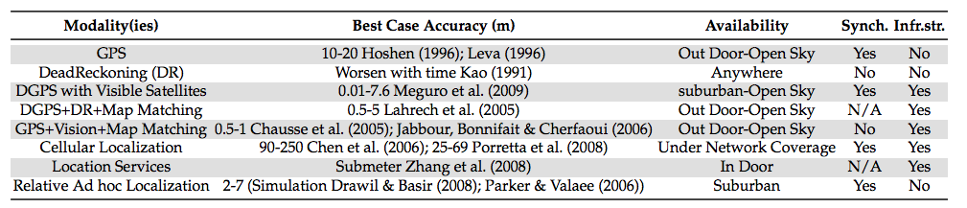

* Implementation requirements
  + GPS receiver, INS, VANET transceiver
* GPS/INS system
  + Kalman Filter
* Multipath Detection Unit
  + Feed Forward Backpropagation Network(FFBN)
  + A classifier trained by discrepancy samples randomly generated in two different simulated environments(open area versus severe multipath region).
* Localization Enhancement Unit
  + Use anchor node and trilateration
* Obst M, Bauer S, Wanielik G. Urban multipath detection and mitigation with dynamic 3D maps for reliable land vehicle localization[C]//Position Location and Navigation Symposium (PLANS), 2012 IEEE/ION. IEEE, 2012: 685-691.

kalman filtering

* 协方差矩阵用来表示这次推测带来的不确定性
* 卡尔曼滤波器是一种利用线性系统状态方程，通过系统输入输出观测数据，对系统状态进行最优估计的算法。而且由于观测包含系统的噪声和干扰的影响，所以最优估计也可看做是滤波过程



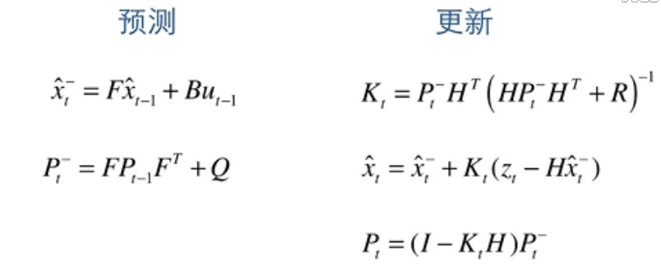

/: prior/posterior state estimate

$$P_{t}^{-}/P_{t}:prior/posterior state covariance$$

$$K_{t}:kalman parameter$$

$$H:observation matrix$$